Geometry I Name: _____________________________Date:_______
Unit # 2 – Angles and Lines
Angles and Parallel Lines – Day 4
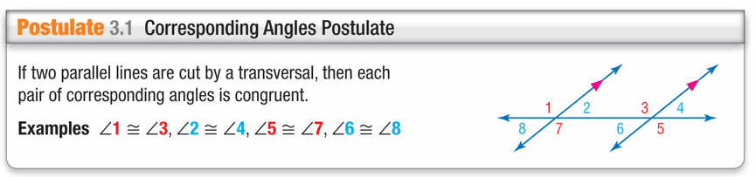

Example 1.
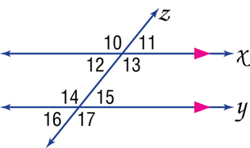
A. In the figure, m∠11 = 51. Find m∠15.

B. In the figure, m∠11 = 51. Find m∠16.
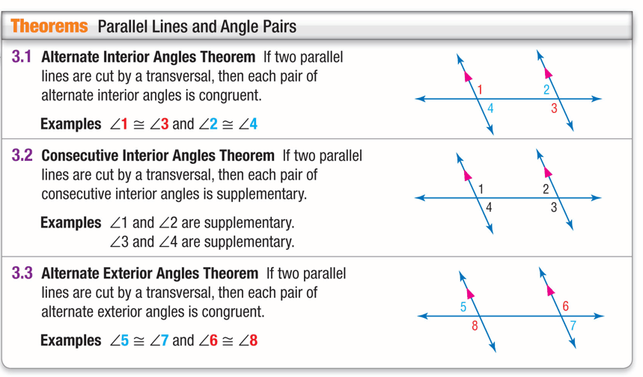

Congruent | Supplementary

Example 2
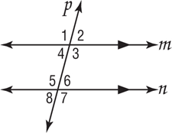
In the figure, m∠2 = 75. Find the measures of the
remaining angles.

Example 3.
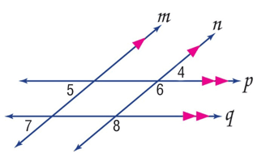
A. ALGEBRA If m∠5 = 2x – 10, and m∠7 = x + 15, find x.

B. ALGEBRA If m∠4 = 4(y – 25), and m∠8 = 4y, find y.

Example 4.
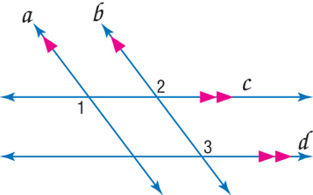
ALGEBRA If m∠1 = 9x + 6, m∠2 = 2(5x – 3), and
m∠3 = 5y + 14, find x and y.

