Geometry Name: _____________________________Date:_______
Unit # 2 – Lines and Angles
Parallel Lines and Transversals – Day 4
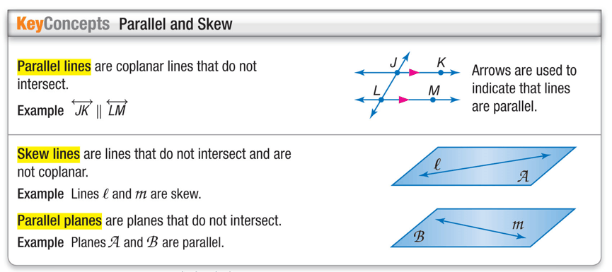
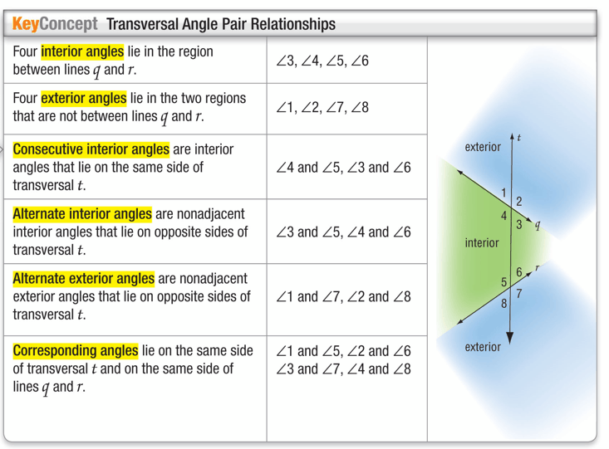

Example 1.
A. Classify the relationship between ∠2 and ∠6 as alternate interior,
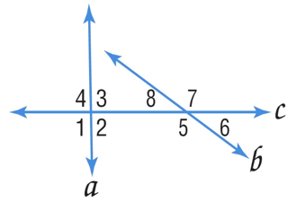
alternate exterior, corresponding, or consecutive interior angles.

B. Classify the relationship between ∠1 and ∠7 as alternate interior, alternate exterior, corresponding, or consecutive interior angles.

C. Classify the relationship between ∠3 and ∠8 as alternate interior,
alternate exterior, corresponding, or consecutive interior angles.

D. Classify the relationship between ∠3 and ∠5 as alternate interior,
alternate exterior, corresponding, or consecutive interior angles.

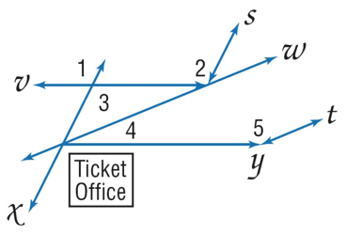
Example 2.
A. BUS STATION The driveways at a bus station are shown. Identify
the transversal connecting ∠1 and ∠2. Then classify the
relationship between the pair of angles.

B. BUS STATION The driveways at a bus station are shown. Identify the transversal connecting ∠2 and ∠3. Then classify the relationship between the pair of angles.

C. BUS STATION The driveways at a bus station are shown. Identify
the transversal connecting ∠ 4 and ∠5. Then classify the
Relationship between the pair of angles.

