Geomety I Name:_____________________________Date:_______
Tools of Geometry – Unit 1
Midpoint Formula – Day 4
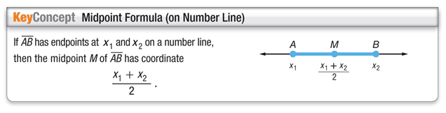
Example 1)
Find the midpoint of each line segment on the number line.
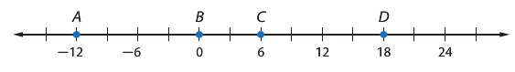
AC BD

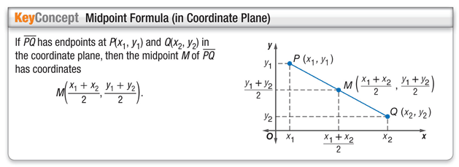

Example 2.
Find the coordinates of M, the midpoint of GH, for G(8, -6) and H(-14, 12)

Example 3.
Find the coordinates of M, the midpoint of GH, for G(-6, 5) and H(9, -3)

Example 4.
Find the coordinates of D if E(-6, 4) is the midpoint of DF and F has coordinates (-5, -3)

Example 5.
Find the coordinates of R if N(8, -3) is the midpoint of RS and S has coordinates (-1, 5)

