Learning Target 17 Guided Notes Name:_____________________________ Date:____________
Congruence Statements

congruent –

congruent triangles -

corresponding parts –

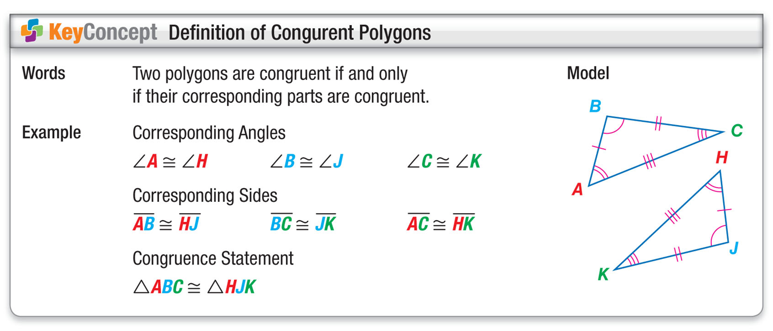
A. If these two triangles are congruent then name the name the corresponding parts.
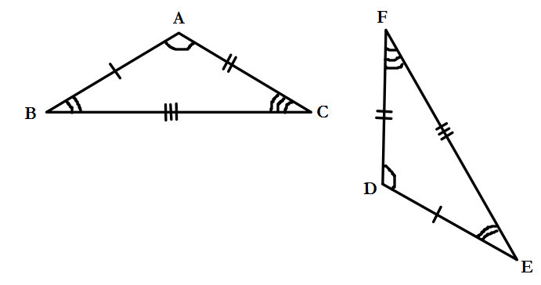

B. Error Analysis: Identify which congruence statements are erroneous.
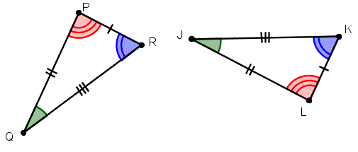

C. The support beams on the fence form congruent triangles. In the figure ΔABC ≅ ΔDEF, which of the following congruence statements correctly identifies corresponding angles or sides?

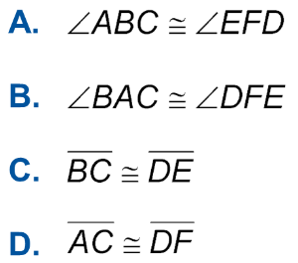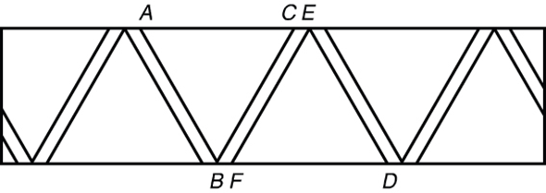

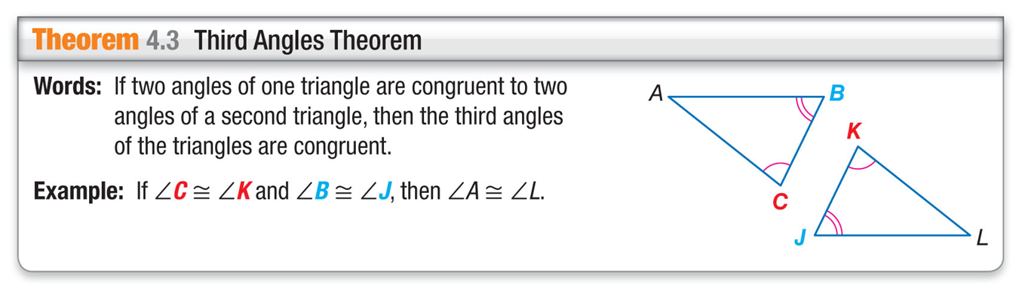

D. In the diagram, ΔITP ≅ ΔNGO. Find the values of x and y.
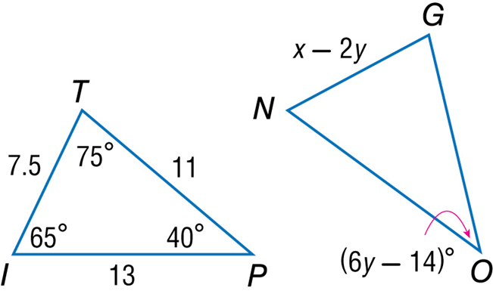

E. In the diagram, ΔFHJ ≅ ΔHFG. Find the values of x and y.
