Learning Target 16 Guided Notes Name:_____________________________ Date:____________
Isosceles and Equilateral Triangles

legs of an isosceles triangle –

vertex angle -

base angles –

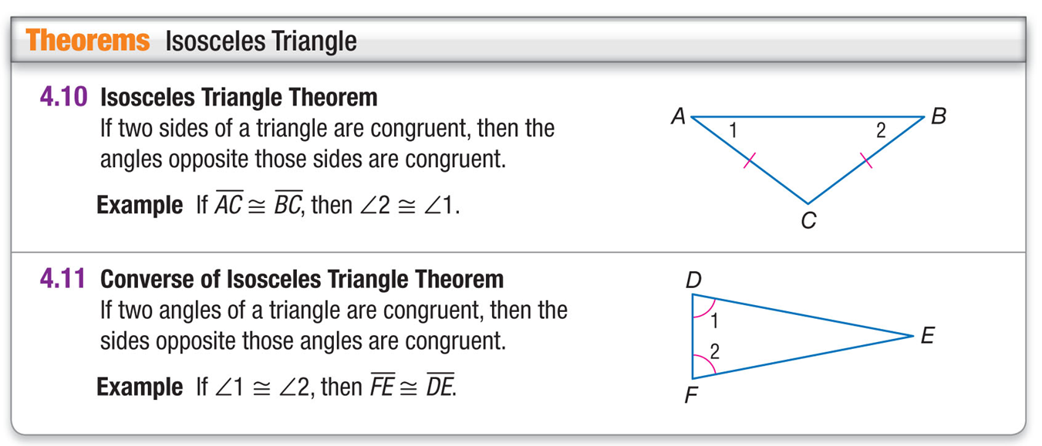

A. Name two unmarked congruent angles.

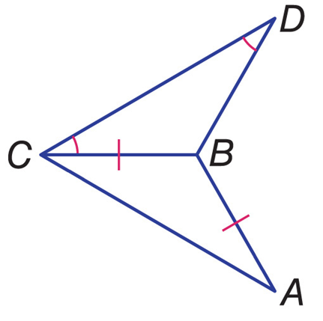

B. Name two unmarked congruent segments.

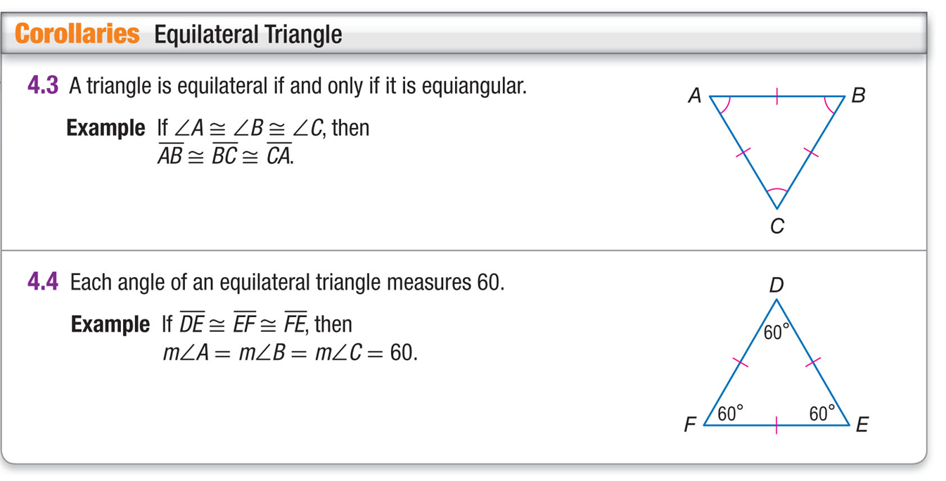
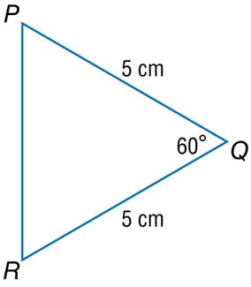
A. Find m∠R.

B. Find PR.

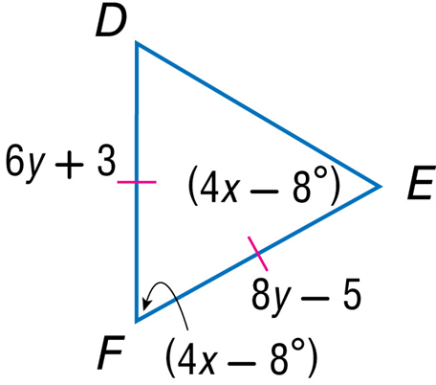
ALGEBRA Find the value of each variable.

