Geometry I Name:_____________________________Date:_______
Tools of Geometry – Unit 1
Distance Formula – Day 3

Distance –

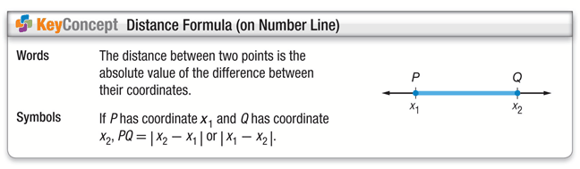
Example 1.
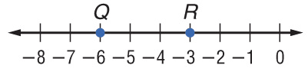
A. Use the number line to find QR.

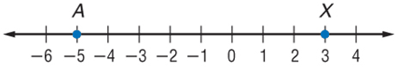
B. Use the number line to find AX

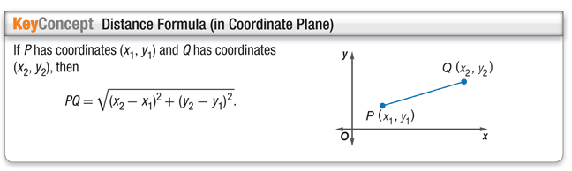
Example 2)
Find the distance between E(–4, 1) and F(3, –1). Round to the nearest tenth if necessary.

Example 3)
Find the distance between D(-1, 7) and F(3, 4). Round to the nearest tenth if necessary.

Example 4)
Find AM. Round to the nearest tenth if necessary.

