Geometry I Name:_____________________________Date:_______
Unit # 2 – Lines and Angles
Angle Relationships – Day 3
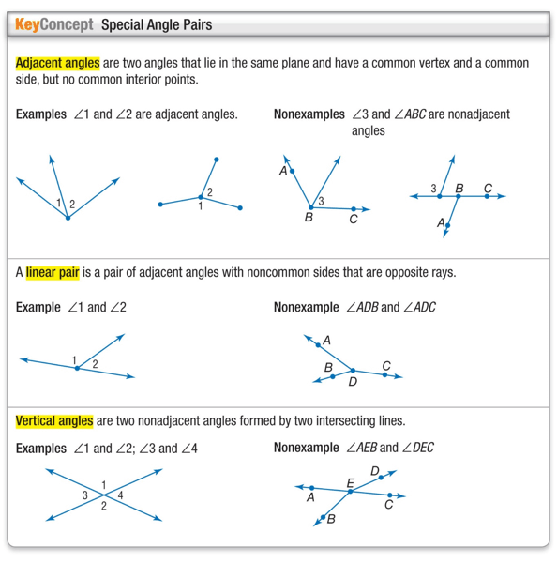
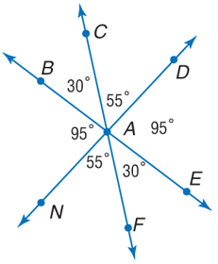
Example 1.
A. Name 2 adjacent angles.

B. Name 2 acute vertical angles.

C. Name 2 angles that form a linear pair.
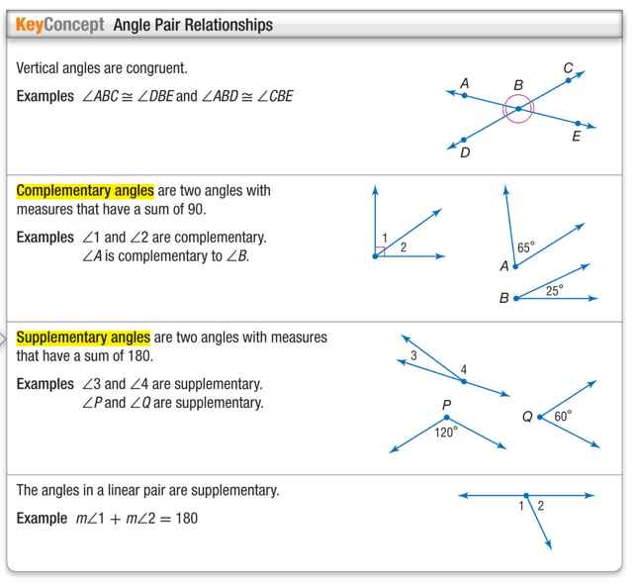

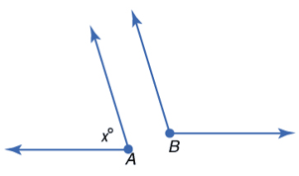
Example 2.
ALGEBRA Find the measures of angle A and angle B
if m A= x and the m B = 5x - 6, and angle A and angle B are supplementary.

Example 3.
ALGEBRA Find the measures of two complementary angles if one angle measure is 2x + 10 and the measure of the other angle is 3x + 5.

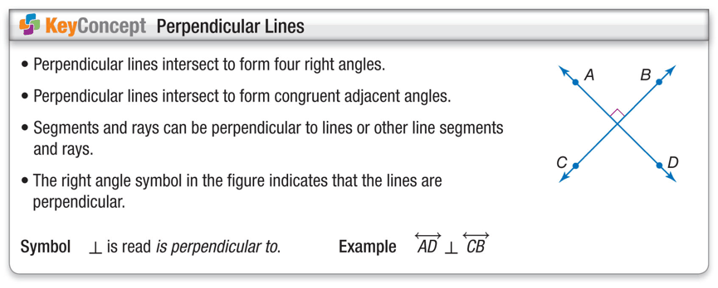
Example 4
ALGEBRA Find x and y so that
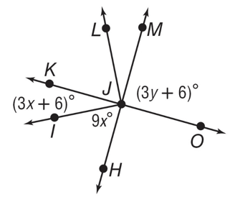
KO and HM are perpendicular.

Example 5
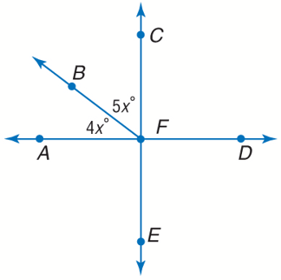
ALGEBRA Find x so that AD and CE are
perpendicular.

