Ionic Bonding: Determining Chemical Formulas

Introduction

Ionic bonds are formed when electron(s) are lost by an atom, and a different atom takes the electron(s). Atoms become ions when the electron transfer takes place. Positive ions, called cations, lack electrons. Negative ions, called anions, have extra electrons. The attraction between positives and negatives is called electrostatic attraction. Oppositely charged ions are attracted to each other, while like charged ions are repelled from one another. The number of electrons that are exchanged is the key to determine a chemical formula. In a compound, the number of positives must be equal to the number of negatives. Compounds do not have + or - signs in them. The + and - charges on the ions have been attracted to each other, and cancel each other out when an ionic compound is formed. If a + or - sign is written, this indicates that an ion exists, not a compound. In order to complete an ionic compound, you must equate the number of positives with the right number of negatives, and vice versa.

Polyatomic ions are covalently bonded groups of atoms that together form a single ion. Their charges do not change, and must be memorized. A list of some common polyatomic ions can be found in Appendix B.

Procedure

1. Color all cations blue and all anions red.

2. Cut out the ions. On a sheet of paper, make the following compounds by piecing the ions together. Glue them in place. Then, write the formula for the compound.

1. Magnesium Chloride 6. Potassium Sulfide
2. Aluminum Sulfate 7. Calcium Hydroxide
3. Hydrogen Fluoride 8. Rubidium Iodide
4. Gallium Nitrate 9. Copper (I) Oxide
5. Lithium Chloride 10. Sodium Carbonate

3. Complete problems 11-40, write the formula without the aid of the cut and paste ions.

11. Mercury (II) Chloride

12. Iron (III) Chloride

13. Hydrogen Iodide

14. Aluminum Oxide

15. Calcium Nitrate

16. Sodium Cyanide

17. Aluminum Bromide

18. Iron (II) Sulfate

19. Lithium Fluoride

20. Silver Carbonate

21. Barium Acetate

22. Ammonium Nitrate

23. Zinc Oxide

24. Tin (IV) Oxide

25. Sodium Arsenate

26. Calcium Oxide

27. Cadmium (II) Chloride

28. Tin (II) Chloride

29. Sodium Phosphate

30. Potassium Chromate

31. Iron (III) Nitrate

32. Chromium (I) Iodide

33. Radium Bromide

34. Ammonium Phosphate

35. Copper (I) Sulfate

36. Ammonium Hydroxide

37. Hydrogen Iodate

38. Calcium Hypochlorite

39. Sodium Oxalate

40. Silver Chloride

Used by permission of Steiner Enterprises. To order CheMags, call 1-800-SARGENT.

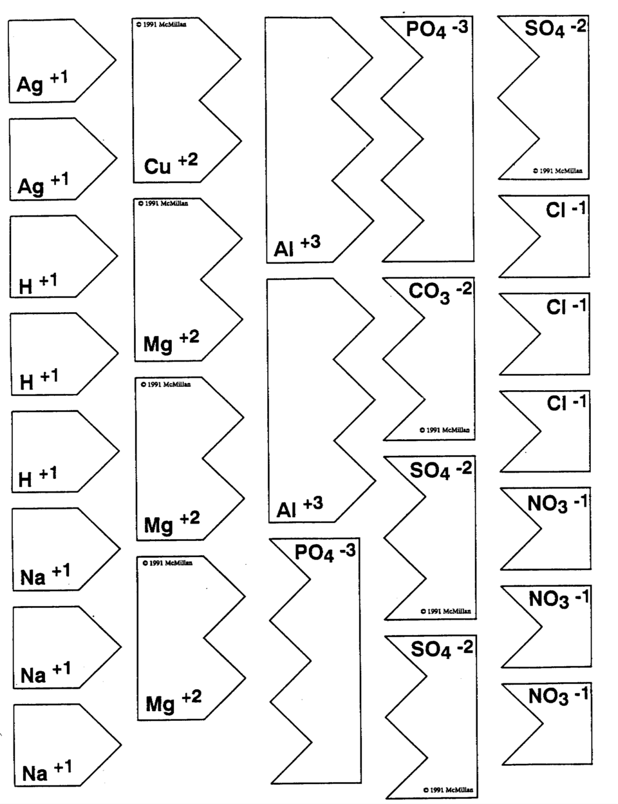
Used by permission of Steiner Enterprises. To order CheMags, call 1-800-SARGENT.

