Geometry I Name:_____________________________Date:_______
Unit # 2 – Lines and Angles
Parallel and Perpendicular Lines – Day 2

Parallel Lines:

Perpendicular Lines:

Writing Opposite Reciprocals
- Make the slope a fraction, if not already.
- Flip the fraction.
- Change the sign. If negative make it positive. If positive make negative.
Examples
$\frac{3}{4}$ 2 $-\frac{1}{3}$
Determine whether AB and CD are parallel, perpendicular, or neither.
Example 1.)

Example 2.)

Example 3.)

Determine whether the two lines are parallel, perpendicular or neither.
Example 4.) Example 5.)

Example 6.)
Graphing
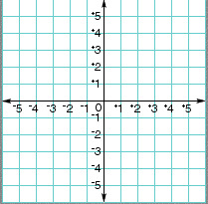
Graph the following.

Example 7.) A line parallel to y = 2x -1
and passes through (2,3)

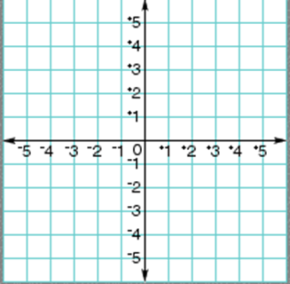
Example 8.) A line perpendicular to
y = 2x -1 and passes through (2,3)

Writing Equations
Example 10.) Write the equation of a line perpendicular to y = -3x +2 and passes through (4, 0)

Example 11.) Write the equation of a line parallel to y = 2x - 5 and passes through (-1, 3)

