Geometry I Name:_____________________________Date:_______
Tools of Geometry – Unit 1
Linear Measure – Day 2
Unlike a line, a ________________________________, or segment, can be measured

because it has two endpoints. A segment with endpoints A and B

can be named as __________________________. The measure of _________ is written as __________.

Example 1) Example 2)

A. Find the length of AB using the ruler.
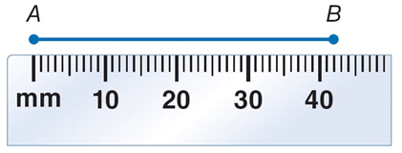
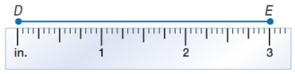

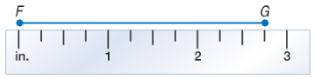
B. Find the length of AB using the ruler.
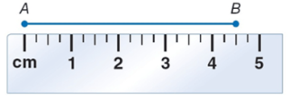

A. Find the length of DE.

B. Find the length of FG.

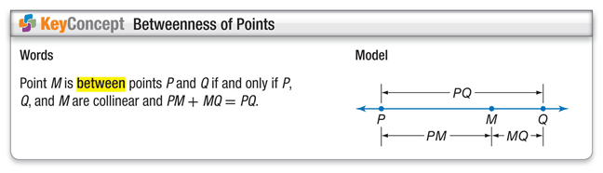
Example 3)
Find XZ. Assume that the figure is not drawn to scale.

Example 4)
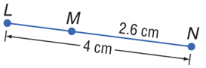
Find LM. Assume that the figure is not drawn to scale.

Example 5)
ALGEBRA Find the value of x and ST if T is between S and U, ST = 7x, SU = 45, and TU = 5x – 3.

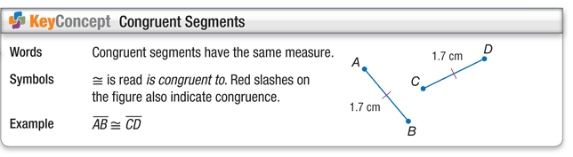
Ray –

Angle –

Sides-
Vertex –
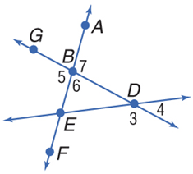
Example 6.
A. Name all angles that have B as a vertex.

B. Name the sides of ∠5.

C. Write another name for ∠6.
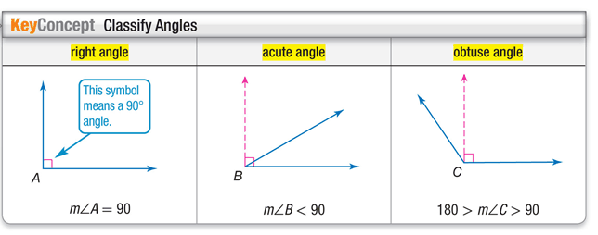

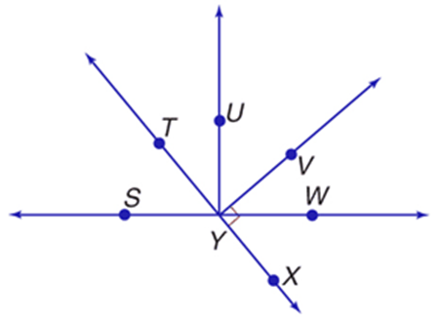
Example 2
A. Measure ∠UYV and classify
it as right, acute, or obtuse.

B. Measure ∠WYT and classify
it as right, acute, or obtuse.

C. Measure ∠WYU and classify
it as right, acute, or obtuse.

