Geometry I Name:_____________________________Date:______
Unit # 2 – Lines and Angles
Slope and Equations of Lines – Day 1

Slope -

Rate of Change -

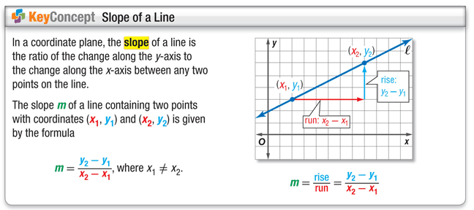
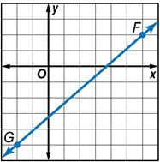
Example 1.)
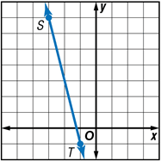
A. Find the slope of the line. C. Find the slope of the line

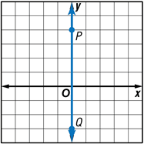
B. Find the slope of the line. D. Find the slope of the line.
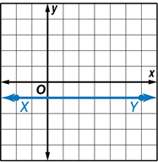

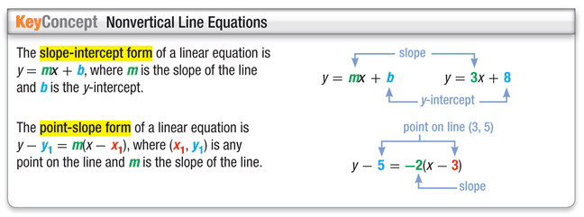
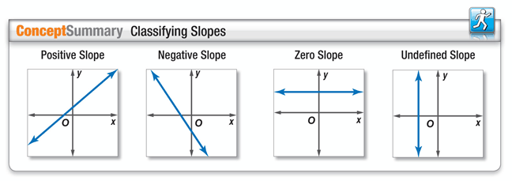

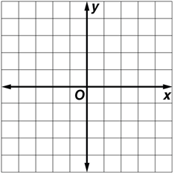
Example 2.)
Write an equation in slope-intercept form of the line with slope of 6 and y-intercept of –3. Then graph the line.

Example 3.)
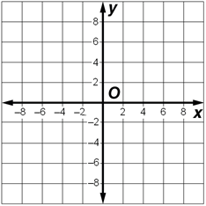
Write an equation in point-slope form of the line whose slope is $-\frac{3}{5}$ that contains (–10, 8). Then graph the line.

Example 4.)
- Write an equation in slope-intercept form for a line containing (4, 9) and (–2, 0).

- Write an equation in slope-intercept form for a line containing (–3, –7) and (–1, 3).

Example 5.)
Write an equation of the line through (5, –2) and (0, –2) in slope-intercept form.

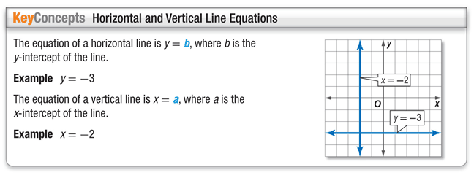

Example 6.)
RENTAL COSTS An apartment complex charges $525 per month plus a $750 annual maintenance fee.
- Write an equation to represent the total first year’s cost A for r months of rent.

B. Compare this rental cost to a complex which charges a $200 annual maintenance fee but $600 per month for rent. If a person expects to stay in an apartment for one year, which complex offers the better rate?

