Geometry I Name:_____________________________Date:_______
Tools of Geometry – Unit 1
Points, Lines, and Planes – Day 1

A point is

Named by

Example

A line is

Named by

Example

A plane is

Named by

Example

Collinear –

Coplanar –

Example 1.
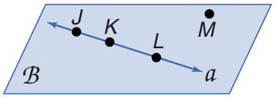
A. Use the figure to name a line containing point K.

B. Name a point not on line a.

Example 2.
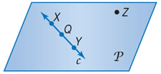
A. Use the figure to name a line containing the point X.

B. Name the plane.

Real World Example 3.
A. Name the geometric shape modeled by a 10 x 12 patio.

B. Name the geometric shape modeled by a button on a table.

Real World Example 4.
A. Name the geometric shape modeled by a colored dot on a map used to mark the location of a city.

B. Name the geometric shape modeled by the ceiling of your classroom.

Example 5.
A. Draw and label a figure for the following situation. Plane R contains lines AB and DE, which intersect at point P. Add point C on plane R so that it is not collinear with AB or DE.

Example 6.
Draw and label a figure for the following. Plane D contains line a, line m, and line t, with all three lines intersecting at point Z. Also, point F is on plane D and is not collinear with any of the three given lines.

Example 7.
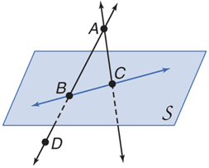
A. How many planes appear in this figure?

B. Name three points that are collinear.

C. Are points A, B, C, and D coplanar? Explain.

D. At what point do DB and CA intersect?

