Name: _____________________________Date:_______
Logic and Proofs – Unit 4
Conditional Statements – Day 1
Conditional Statement:
Short hand for an if-then statement

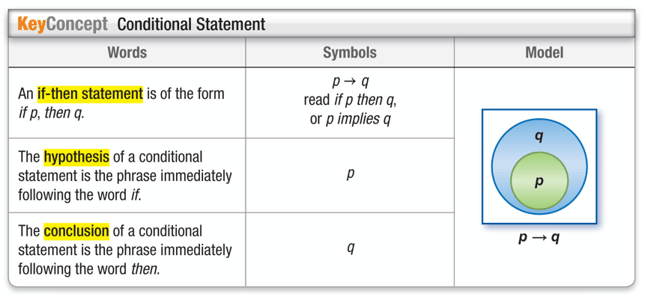
Example 1. Identify the hypothesis and conclusion of the following statement.

A. If a polygon has 6 sides, then it is a hexagon.

B. Tamika will advance to the next level of play if she completes the maze in her computer game.

Example 2. Identify the hypothesis and conclusion of the following statement. Then write the statement in the if-then form
A. A mammal is a warm-blooded animal.

B. A five-sided polygon is a pentagon.

Truth Values
The hypothesis and conclusion of a conditional statement can have a truth value of true or false, as can the conditional statement itself. Consider the following example.

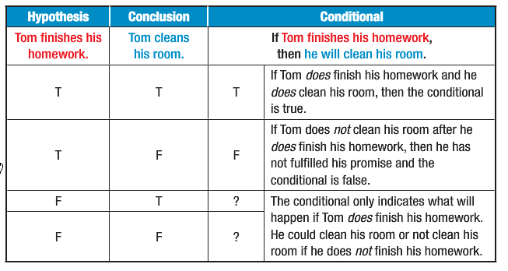
If Tom finishes his homework, then he will clean his room.

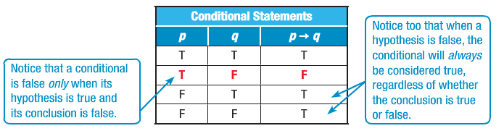
Example 3. Determine the truth value of the conditional statement. If false, give a counterexample.
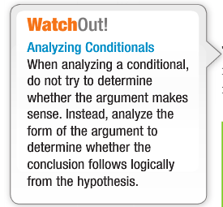
A. If you divide an integer by another integer, the result is also an integer.

B. If last month was February, then this month is March.

C. When a rectangle has five sides, it is a parallelogram.

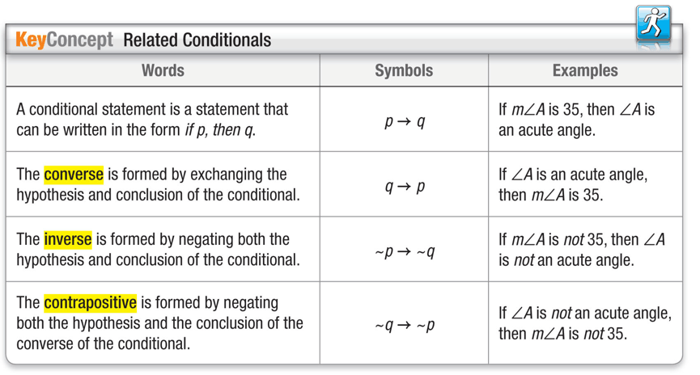
Example 4. Write the converse, inverse and contrapositive of the following.
Two angles that have the same measurement are congruent.
CONVERSE:
INVERSE:
CONTRAPOSITIVE:

