Learning Target 14 Guided Notes Name:_____________________________ Date:____________

Classifying Triangles

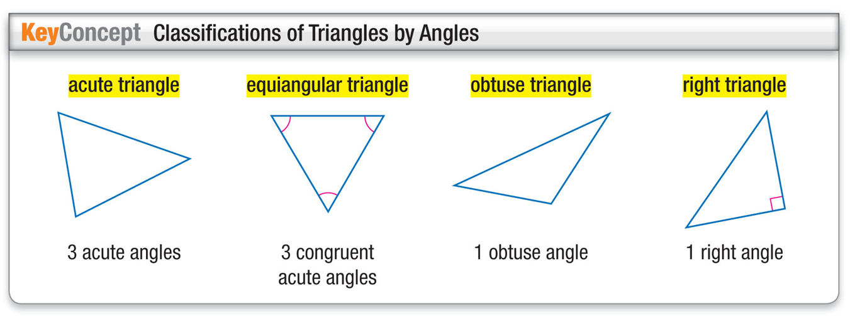

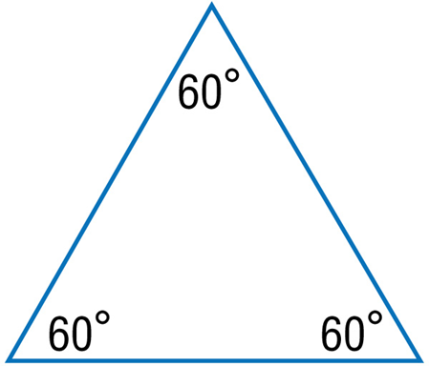 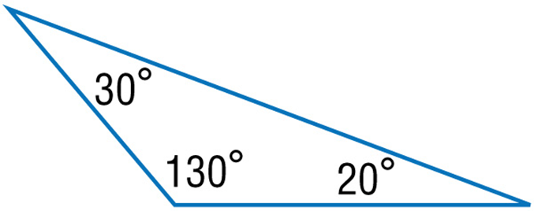

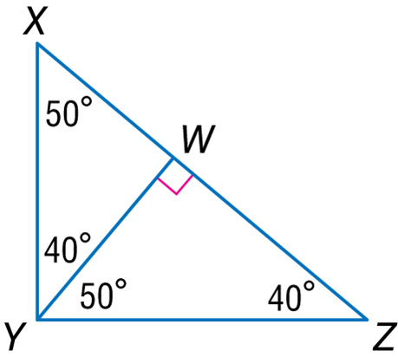

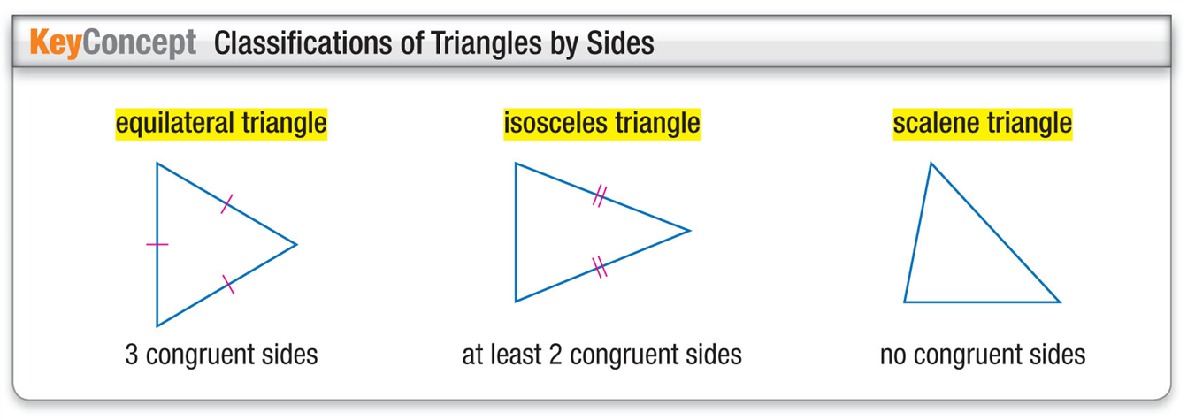

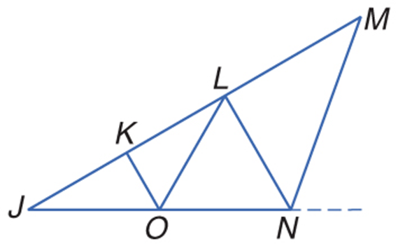 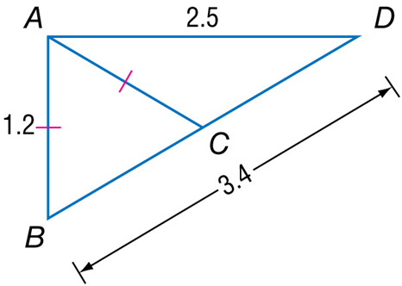

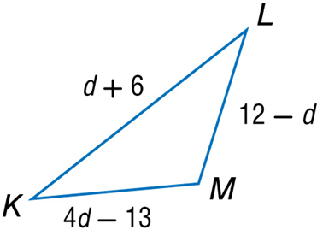

**A(-2, 3), B(2, 2), C(1, -2)**